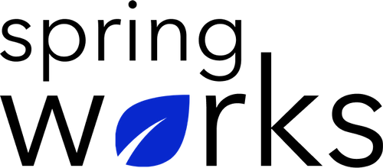
Free Template – Team Performance Survey

Use this survey to gain insights into your team’s performance.

A team performance survey is necessary to analyze how effective is the work that is done, and what are the improvements required.

Communication (to be added as review instructions):

Your responses to this survey are anonymous. Please answer this quick survey by <HOUR OF THE DAY> on <DATE>.

Thank you for your time. Your responses will help our organization become a better place to work. If you have any questions about the survey, please contact [insert name of contact person].

Demographic Information:

The following information is requested so that meaningful analysis and comparisons of group results can be made. Please check the circle corresponding to your answer.

Q: Your Gender:

- Male
- Female

Q: Your Department:

- Marketing
- Operations
- Tech
- Accounting
- HR

Q: Company Service:

- Under 1 Year
- 1-2 Year
- 3-5 Year
- 6-10 Year
- 10-15 Year
Team Performance Questionnaire

To answer clearly what you think or feel about each item, please follow these steps:

- Read each item fully before you start to mark your answer.
- Pick the one answer which most nearly says what you think or how you feel.
- While completing the questions, be sure to read the special instructions which are included.

Choose the most appropriate answer:

Q: My team-members are efficient in their roles:

- Strongly agree
- Agree
- Neutral
- Disagree
- Strongly disagree

Q: My team-members offer to help when someone is stuck in their tasks:

- Formal
- Semi-formal
- Informal
- Too informal

Q: My team-members know how to work in a professional environment:

- Strongly agree
- Agree
- Neutral
- Disagree
- Strongly disagree

Q: My team-members share responsibilities well:

- Strongly agree
- Agree
- Neutral
- Disagree
- Strongly disagree

Q: They share good communication among each other:

- Yes
- Maybe
- Often
- No

Q: Number of the team meetings per week:

Answer:

Q: Number of team-members:

Answer:

Q: The size of my team is:

- Too large
- Large
- Normal
- Small
- Too Small

Q: Overall, the team-performance is:

- Extremely satisfying
- Satisfying
- Neutral
- Dissatisfying
- Extremely dissatisfying

Q: Best qualities about your team:

i.
ii.
iii.

Q: Qualities about your team that can be improved:

i.
ii.
iii.

